Commerce bank Financial , Uniondale, NY
Feb 07- July 08, Business Data Analyst
Environment: SQL loader, MS Visio, MS Project, TOAD Manager, Quick Test Pro 8.2, Bugzilla, Oracle 9i, Softek TDMF Technology, Business Objects XI R2, Essbase 5/6, Hyperion.

Commerce bank Financial Corporation, through its subsidiaries, provides various financial products and services to consumers, small businesses, and commercial clients. The company offers commercial and consumer loans, commercial and consumer deposit account services, commercial credit cards, treasury management services, trust services, and other banking related products, such as insurance, brokerage services, merchant services, and investment banking, as well as provides money market and certificate of deposit accounts through Internet channels.
The project involved setting up of direct deposit of the Payroll Department for Commerce bank’s clients, this involved setting up of ACH gateway. Our team was also responsible for design of SSH functionality using batch processes for data transfer from various systems and SSH for remote monitoring and management of servers for copying files from local server to remote host.

Responsibilities:

- Managed requirements from system users and preparation of business requirement documents using Rational Requisite Pro that provided appropriate scope of work for technical team to develop prototype and overall system.
- Created UML based diagrams using Rational Rose and MS-Visio for Use Cases and Activity Diagrams, for better understanding of the layout of the new process.
- Gathered the functional and business requirements by conducting JAD sessions and participatory Design Sessions involving major leads from the Technical Department.
- Used SSH for remote monitoring and management of servers for copying files from local server to remote host
- Performed data conversion, stratification and quality control testing of interim and final data and preparation of all reports and data transmissions to client for projects
- Extracted data from Oracle into temporary tables in order to cleanup and standardize column entries for re-import into new Oracle data structures. Used extensive ad-hoc queries to create/modify/delete data
- Responsible for researching and writing functional specification documents for custom Lotus Notes database projects for Commerce bank ACH (CIF, 2 new databases).
- Worked extensively on Static, ad hoc, automated and dynamic Hyperion Essbase reporting.
- Developed a Hyperion Essbase reporting solution to facilitate a more efficient ways of reporting process.
- Gathered requirements and participated in database design and development as well as report design and development, testing plan co-development and quality assurance.
- Generated Executive Problem Management Reports in excel with Essbase.
- Extracted data from Oracle into temporary tables in order to cleanup and standardize column entries for re-import into new Oracle data structures. Used extensive ad-hoc queries to create/modify/delete data.
- Oversaw the implementation of Encryption Gateway Server of Managed File Transfer platform supported via protocols like PM4Data, SFTP, Connect Direct Desktop, and SSL VPN Max infrastructure.

Wholesale banking is commonly defined as banking services that are provided between merchant banks and other financial institutions. However, wholesale banking is often used as a term to refer to the wide range of financial services that are provided by financial institutions to various corporations and businesses, as well as to government entities. Wholesale banking is different from retail banking, in that the former focuses more on corporate style entities and high value transactions, while the latter is focused on providing financial services to individual consumers. Thus, a bank will typically engage in both wholesale and retail banking.

A merchant bank deals with the commercial banking needs of international finance, long-term company loans, and stock underwriting. This type of bank does not have retail offices where a customer can go and open a savings or checking account. A merchant bank is sometimes said to be a wholesale bank, or in the business of wholesale banking. This is because merchant banks tend to deal primarily with other merchant banks and other large financial institutions.
The most familiar role of the merchant bank is stock underwriting. A large company that wishes to raise money from investors through the stock market can hire a merchant bank to implement and underwrite the process. The merchant bank determines the number of stocks to be issued, the price at which the stock will be issued, and the timing of the release of this new stock. The bank then files all the paperwork required with the various market authorities, and is also frequently responsible for marketing the new stock, though this may be a joint effort with the company and managed by the merchant bank. For very large stock offerings, several merchant banks may work together, with one being the lead

The chief distinction between an investment bank and a merchant bank is that a merchant bank invests its own capital in a client company whereas an investment bank purely distributes (and trades) the securities of that company in its capital raising role.

As useful as file transfer over SSH can be, it has not replaced SSL based applications. This means that most users need to ensure that their data communications system is able to easily handle both styles of protocol, especially when dealing with third parties that may be using unknown software. Momentum Systems offers the perfect solution with the Secure Network Gateway suite. In addition to allowing file transfer over SSH and SSL based FTP, this full function software will be the answer to your other data communication needs. Handling FTP, HTTP, fax, email and other functions, it is a crucial component in your secure network design. The Secure Network Gateway software is efficient and easy to implement. It is managed file transfer software designed to take care all of your data communication needs and is easily used in industry with specific secure data communications needs such as banking

Using UNIX Shell prompt to upgrade :

- Back up existing files
- Download latest software
- Overwrite all new files

Tell me about your experience with Wholesale products, specifically Treasury Management Services?
At Commerce bank, I was the primary BA responsible for setting up tools for Commerce bank’s commercial customers. I worked on an application that helped Commerce bank’s customers to set up direct deposit of Payroll through ACH for Commerce bank customers’ employees.

What is NACHA?

This is an Electronic payment association, which oversees the ACH network a safe, efficient, green, and high-quality payment system. NACHA is responsible for the administration, development, and enforcement of the NACHA Operating Rules and sound risk management practices for the ACH Network. Through its industry councils and forums, NACHA brings together hundreds of payments system stakeholder organizations to encourage the efficient utilization of the ACH Network and develop new ways to use the Network to benefit its diverse set of participants. NACHA represents nearly 11,000 financial institutions through direct membership and 18 regional payments associations. NACHA and its members provide education, tools, and resources to increase the adoption of ACH payments to benefit businesses, consumers, and governments.

What exactly NACHA does?
Rule Making
NACHA provides the legal foundation for the ACH Network through the development and enforcement of the The NACHA Operating Rules. Rules and guidelines are established for all participants in the ACH system and ensure that the Network infrastructure, applications, rules and enforcement are consistent with processing payments in a secure, reliable, and efficient manner, and that financial institutions have access to effective risk management tools.
Education
NACHA educates its direct members, the regional payments associations, and the public through a diverse offering of conferences, workshops, teleconferences, and publications. Topics covered include ACH fundamentals, Rules updates, risk management, global payments, electronic check, electronic billing and payment, and more. NACHA also offers the Accredited ACH Professional (AAP) program exam each October to individuals seeking industry credentials.
New Payments Applications
NACHA develops new payments applications through an open and disciplined process that measures the impact on all Network participants, including originators and receivers, and is responsive to the priorities of depository financial institutions.
Risk Management
NACHA develops and implements a comprehensive risk management framework for the Network that covers requirements prior to origination, ongoing origination requirements, and enforcement, and ACH Operator risk mitigation services. NACHA also works to create and implement a robust set of risk management tools to reduce risk and improve ACH quality that are consistent with the risk management framework.
Member Communications
NACHA promotes and consistently communicates the value and best uses of electronic payments to depository financial institutions and their customers through marketing, public relations, and education. Additionally, NACHA broadly engages key external audiences to communicate the value proposition of the Network and ACH Payments.
Marketing
NACHA actively promotes the value and use of electronic payments through educational materials, events, speaking engagements, advertising, and television and radio promotions. Additionally, NACHA coordinates the annual Direct Deposit and Direct Payment (May) national campaign, highlighting the benefits of Direct Deposit for payroll, pension, and Social security payments.
Regulatory and Government Relations Issues
NACHA establishes and maintains formal relationships with key industry audiences, including the Federal Reserve System and the U.S. Department of the Treasury and responds expeditiously to regulatory and government relations issues.

What is PGP, how does it work? Where did you use it?
PGP is an encryption algorithm, stands for Pretty Good Privacy. This was invented by Philip Zimmerman in 1991. In this every user has two keys to encrypt and decrypt. There is one Public and the other one is a secret key. The public key is sent out to the client or the clients use your public key to encrypt the message. The secret key is used to decrypt the message, either the message sent by the client or your own message. Usage of PGP.
- Create a directory for PGP:
For example,
cd
mkdir .pgp

- Set the environment variable PGPPATH to point to this directory:
If you are using csh, do the following:
setenv PGPPATH $HOME/.pgp
- Generate your private and public keys:
pgp -kg

For example:
John Q. Public

When you are asked for a pass phrase, type in a good pass phrase. You can use
pwcheck -h math

to check if your pass phrase is not easy to guess. You will be asked to type in some random text.
You need to go through this process just once.
- Encrypting documents:
Once you have generated your keys, you can encrypt a file yourfile by simply typing:
pgp -e yourfile

When you are prompted with:
A user ID is required to select the recipient's public key.
Enter the recipient's user ID:

Type in the user ID you chose during the key generation process. (e.g: jqpublic@UWATERLOO.CA) The encrypted file will then be created with the name yourfile.pgp. You do not need to use a pass phrase for every document you encrypt. You can now remove the original yourfile.
- Decrypting documents:
To decrypt yourfile.pgp, type
pgp yourfile.pgp

When you are prompted for a pass phrase, type in the personal pass phrase you chose during key generation.
As mentioned before, PGP provides many other facilities such as provision of e-mail privacy. For more detailed information do:
man pgp
Even more detailed documentation can be found in the files:
/software/pgp/doc/pgpdoc1.txt.Z
/software/pgp/doc/pgpdoc2.txt.Z
You can use the zmore command to read this documentation

Where did I Use it?

This type of file transfer was generally used for internal purpose and for client reporting. We used it when we had to transfer the files of the employees having their information about their account number, SSN Number, Credit history, Checking and saving outstanding, Tax reports and other.
On the request from the internal departments or from the client enrolled with direct deposit, the files were transmitted using PGP encryption.

Tell me about your experience with ACH?
Identifying who the ACH originator was! Got involved in discussions with whether we should go with CCD format or CTX format. Went with CCD format! Why did you choose CCD format?

What is ACH?
Neha to succinctly explain about ACH in 4 lines. Answer that flows!

What is PKI?

Public Key infrastructures is a set of hardware, software, people need to manage, create, store, and distribute and revoke digital software. This is an arrangement which binds public keys with their respective user identities by means of CA (Certificate Authority). This has to be unique for every user. The registration authority helps in biding the confidentiality pertaining to the users public key. A PKI is an arrangement that binds public keys with respective user identities by means of a certificate authority (CA).
The alternative approach to the problem of public authentication of public key information is
- Web of trust: The best approach in a PGP type for web of trust is that it can incorporate with a PKI CA fully trusted by all parties in a domain that is willing to guarantee certificate.
- SPKI: Simple Public Key Infrastructure. The SPKI specification defines an authorization certificate format, providing for the delineation of privileges, rights or other such attributes (called authorizations) and binding them to a public key.

As a Business analyst, we also developed the Direct deposit payroll cost calculator
The purpose of this calculator is to provide a tool to use in calculating the costs of converting to Direct Deposit of payroll rather than writing payroll checks.

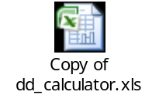
The Automated Clearing House (ACH) network is a highly reliable and efficient, batch-oriented electronic funds transfer system. NACHA-The Electronic Payments Association develops the rules and standards which provide for the interbank clearing of electronic payments for participating depository financial institutions. Both the Federal Reserve and Electronic Payments Network act as ACH operators, or central clearing facilities through which financial institutions transmit or receive ACH entries

How to set up a ACH payment gateway?

From Clients perspective!!!!!!!!!!!

How to set up an ACH transmission with Commerce bank, these are the preliminary steps which have to be followed:

- Identify your ACH originator. In this case it is going to be Commerce bank (US banks can provide this feature)
- Choose either CCD Format ( Cash concentration or Disbursement) or CTX file format ( Corporate trade exchange) in this case for Commerce bank we abide by the CCD format
After the above process the testing and certification process follow up, upon that the banks and the clients are able to transact money using the ACH method.

This electronic payment method is regulated by NACHA (National Automated Clearing House Association).

- When determining which ACH format method suits your company’s needs several factors should be considered implementation, technical components, cost and convenience.
- For payroll format banks and Commerce bank generally uses the PPD format which is similar to the CCD format
- If the clients already use EDI (electronic Data Exchange) they can remit the money using the ACH/CTX format.

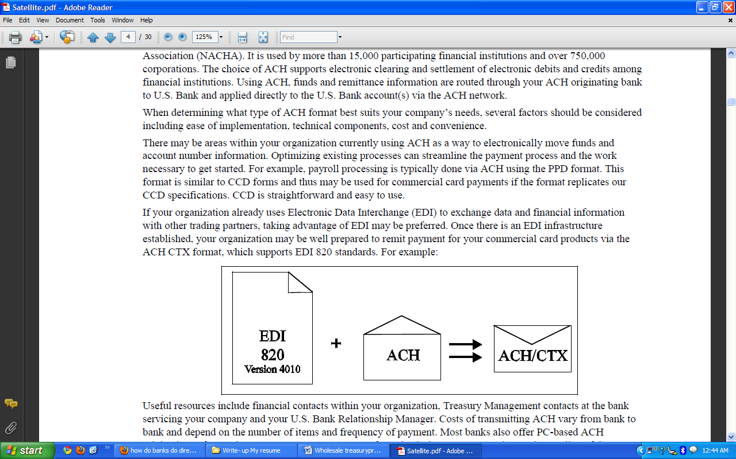

In Oracle, the ACH.rdf file needs to be customized to meet the Bank's requirements. Commercial ACH Batches must have CCD in the Header info, while Employee reimbursements must have PPD in the Header info.

ACH SET UP, TESTING AND CERTIFICATION PROCESS FLOW

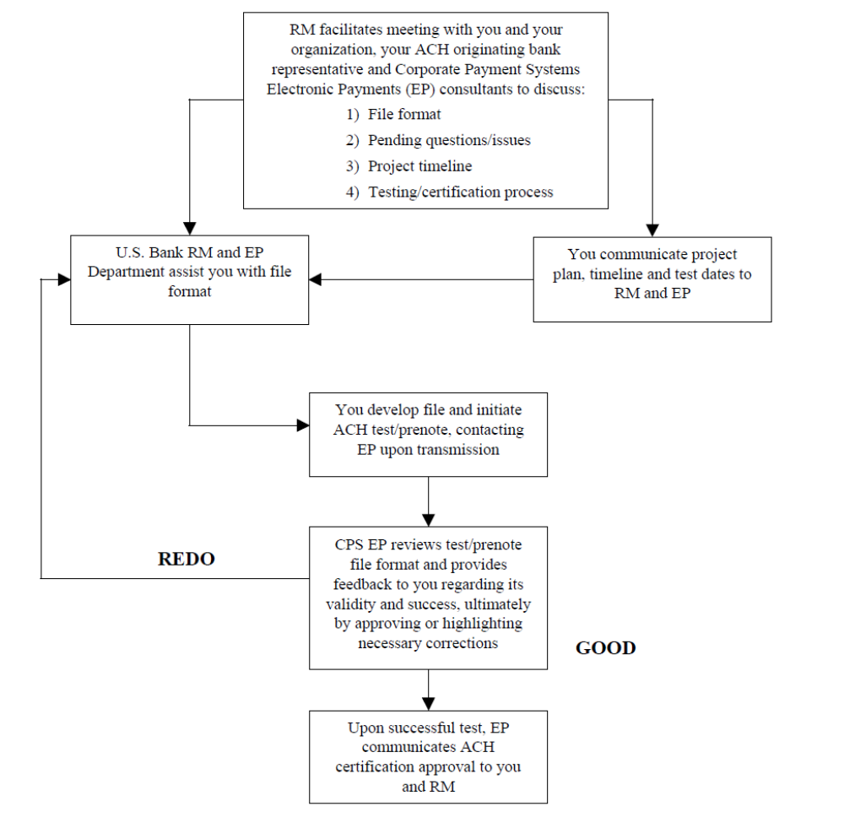

ACH PAYMENT PROCESS FLOW

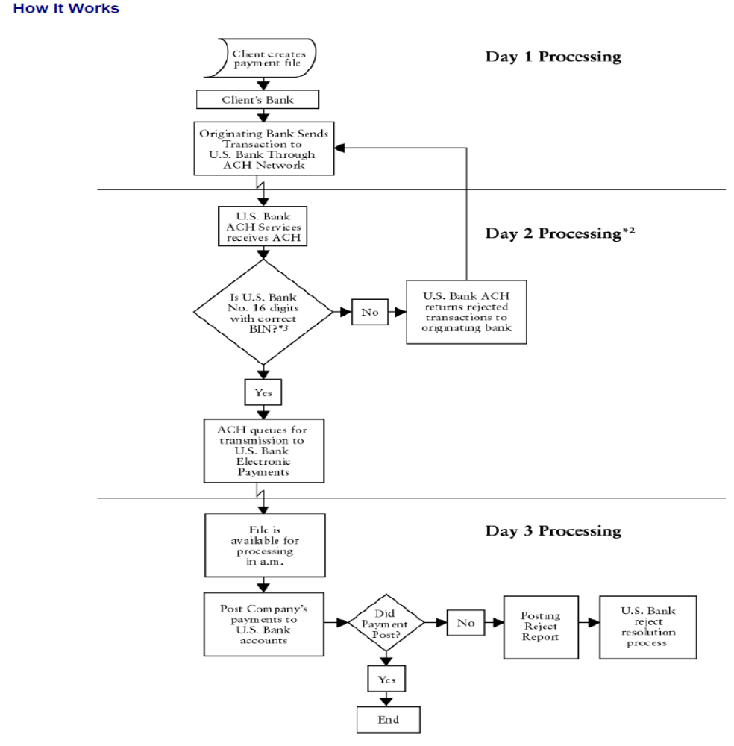

What is CCD Format?

This is a straight forward format and is easy to use. It provides opportunity to include remittance data using detail record. The detail record covers US banks 16 digit and type of payment code. It is required that the format CCD follows the NACHA format

Formatting Highlights:

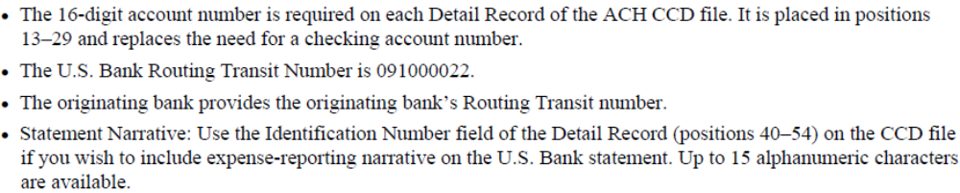

ACH CCD Diagram

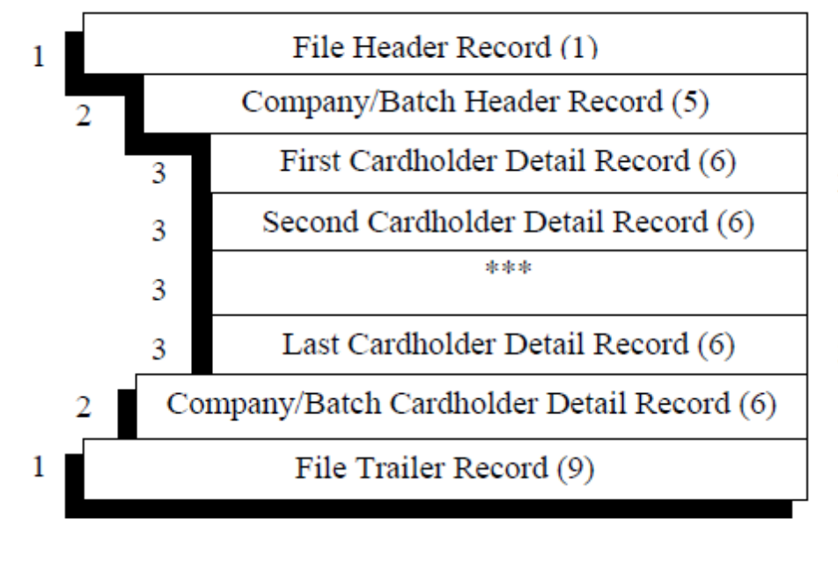

ACH CCD SAMPLE FILE FORMAT
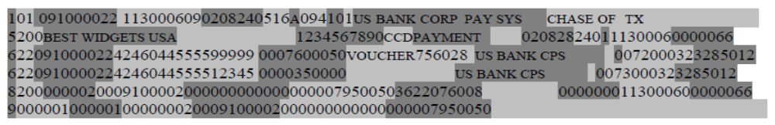
ACH FILE SPECIFICATION:
The following is the specification format for payroll department where the company creates a direct link

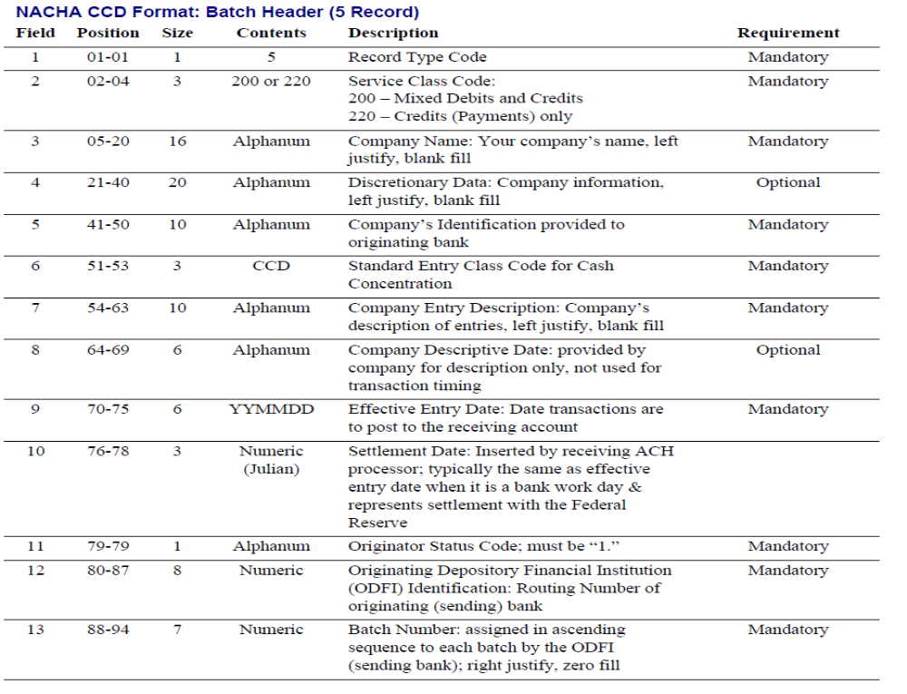

For companies using EDI they can remit using the CTX format

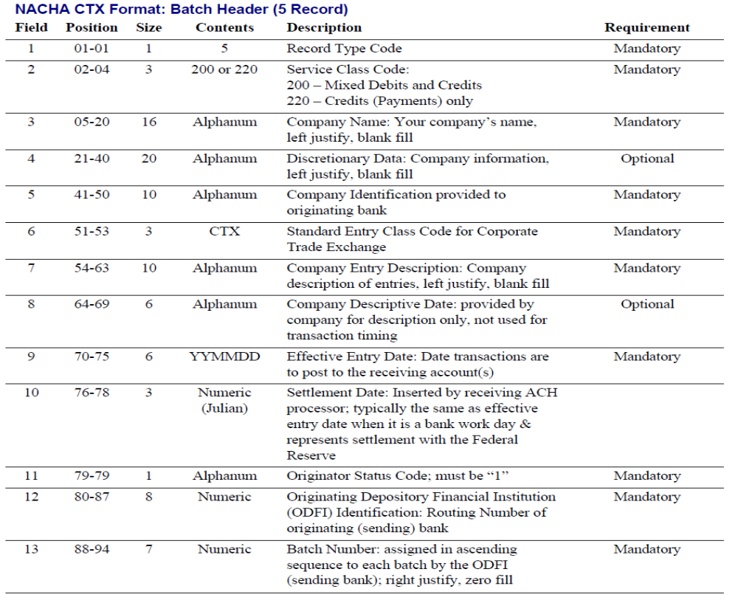

The Data transfer schedule for during the project

Employee Bankers 1
Employee
Bankers 2
Employee
Bankers..N!
Local Server

This server contains the information of the client’s i.e. companies which hook up their payroll with Commerce bank
sFTP over SSH Network
Clients i.e. Company 1
sFTP over SSH Network
sFTP over SSH Network
Clients i.e.
Company 2

Clients i.e.
Company …..N!
REMOTE HOST

Stores the information of the bankers account number, address, SSN and other details this server stores the information of all the employees bank accounts and the money they receive from the direct deposit i.e. payroll Dept of their company

Commerce Bank Project TeamWOW!


Company Profile
Commerce is one of the nation's fastest growing financial services retailers. Since its inception in 1973, Commerce has expanded substantially since opening its first store 34 years ago in Marlton, New Jersey. Today, the Commerce network comprises nearly 450 convenient stores and over 15,000 employees throughout New Jersey, New York, Connecticut, Pennsylvania, Delaware, Washington, DC, Virginia, Maryland & Southeast Florida.

The homepage for Commerce TeamWOW! integrates content from Site Refresh, Weather.com and stock ticker information.

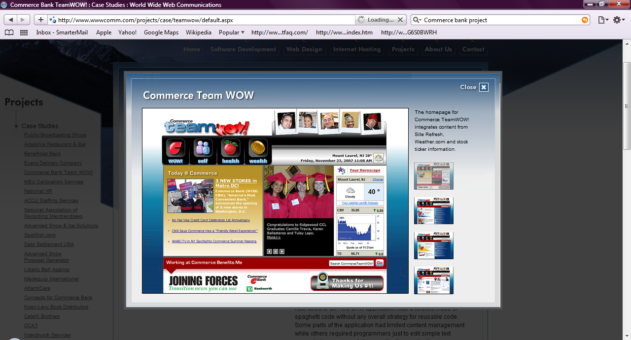

The Health section uses AJAX to dynamically display results, allowing employees to quickly search HR content.

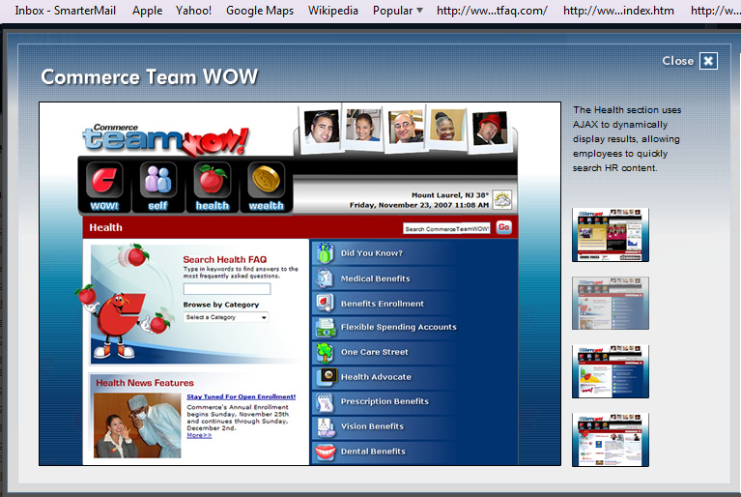

Commerce is able to control the different sections appearing in the graphic navigation on the Wealth landing page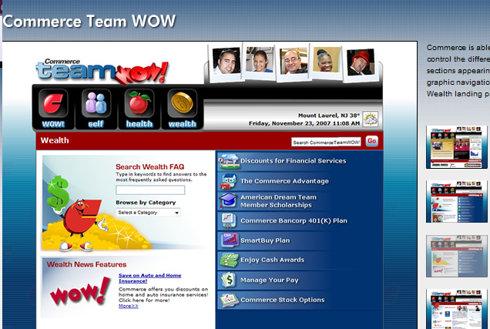

Project Summary
Commerce presented us with a challenge to redesign the CommerceTeamWOW! (CTW) Intranet application while maintaining the existing legacy application. The goals of the redesign were the implementation of an enterprise content management system, Site Refresh, conversion of the code to .NET, and improve the usability of the application for Commerce employees.

Challenging Situation as a BA
The first step was to document and assess the existing application, something that the previous development company had failed to do. The CTW application was a twisted mess of spaghetti code without any overall strategy for reusable code. Some parts of the application had limited content management while others required programmers just to edit simple text areas. In the process of documenting the application, we discovered significant security flaws in the application, and developed code to patch these holes.

Once the documentation was complete, we assumed the responsibility for day-to-day maintenance of the application from the previous development company. We also worked with the IT staff to develop a strategy to convert all parts of the application to .NET and Site Refresh.
This 18-month strategic plan allowed us to find the “low-hanging fruit” for migration of large sections of content and target the larger and more complex parts of the application for redesign with more useful features.
We worked with a variety of business units, IT and CTW to develop detailed scope documents that established the application requirements and project scope for all of the different parts of the application. Along the way, we identified parts of the application that could be designed for significant reuse throughout the application.

A good example of our strategy is shown in WOW! Discounts, an application that allows Commerce employees to find exclusive discounted offers by business customers. The old application forced Commerce employees to scroll through 50+ pages of different listings. With the expansion of the bank into many more states, we recommended implementing better categorization and mapping for the discounted offers. Our solution integrated web services from MapQuest allowing Commerce employees to browse different offers by location and category. Within 3 weeks of launch of the new WOW! Discounts application, our partners at Commerce reported that for one of the discounted offers for mobile phones, employees had gone from an average of 10 sign-ups per month to over 10 sign-ups per week which resulted in a better discounted rate (from 8% to 15%) for Commerce employees. The overall success of this application was reported by the employees of Commerce as they found more discounted offers, and by the merchants offering the discounts as they reported more traffic to their businesses by Commerce employees.

Benefits
Content is managed by non-technical staff using a simple WYSIWYG editor and takes advantage of the customizable workflows in Site Refresh for administrative approval of new content assets. Object-oriented development strategy has produced cost savings from the reuse of code throughout the application. New designs for the application have improved the overall usage of the application by Commerce employees.

BNY Mellon Treasury Services Expands Suite of Payment Solutions for Corporate Clients with the Addition of MasterCard Payment Gateway(TM)
NEW YORK and PURCHASE, N.Y., Dec. 21 /PRNewswire-FirstCall/ -- BNY Mellon Treasury Services and MasterCard Worldwide (NYSE: MA) today announced that BNY Mellon will be integrating the MasterCard Payment GatewayT into its suite of payment solutions for corporate clients. Complementing the ACH, wire transfer and check payment services already available from BNY Mellon, the MasterCard Payment Gateway will allow BNY Mellon clients to take advantage of the speed, cost efficiency, security and disbursements management benefits of electronic B-to-B card payments as part of a comprehensive array of payment alternatives.
An industry leader in the delivery of global payment services to large corporations and institutions, BNY Mellon will utilize the MasterCard Payment Gateway as an electronic B-to-B payments network connecting clients with their suppliers. The MasterCard Payment Gateway will enable BNY Mellon to expand how it addresses its corporate customers' needs across a broad set of spend categories and large value payments. Integration of the Gateway is scheduled for completion by the end of this year.
"Making the benefits of electronic payments processing more readily accessible to our clients is a key strategic focus for us," said Al Briand, managing director and head of product development and strategic development at BNY Mellon Treasury Services. "The ability of new, innovative B-to-B card programs to deliver the advantages of straight through processing - speed, reliability, efficiency and compatibility with advanced cash management strategies and systems - make them a perfect fit for our suite of payment solutions."
"With payments as our core business, MasterCard is focused on providing BNY Mellon and its corporate clients with flexible payment processing capabilities that can easily integrate with and enhance existing ERP and electronic invoicing investments," said Shari Krikorian, Vice President, Innovative Platforms, MasterCard Worldwide. "The global scope of BNY Mellon's payments program, its track record for innovation and knack for incorporating client-friendly modular enhancements to its platforms make it an important addition to our growing roster of Payment Gateway users, and we look forward to working with BNY Mellon on the successful integration of the Gateway into its suite of solutions."
About MasterCard Payment Gateway
First introduced in October 2007, the MasterCard Payment Gateway is a flexible enterprise-wide payment processing platform for routing commercial payments between buyers, suppliers and their financial institutions. Providing a comprehensive, end-to-end, modular solution that offers several key features, including buyer-initiated P-Card straight through processing, the platform significantly enhances security and control for financial institutions and their corporate customers. Other features include single interface ("one stop shop") for all payment processing needs for both buyers and suppliers; user interface/Web portal for payment status and reporting; end-user integration (with current ERP/AP systems) for buyers; and remittance information regardless of payment type for suppliers.
About MasterCard Worldwide
MasterCard Worldwide advances global commerce by providing a critical economic link among financial institutions, businesses, cardholders and merchants worldwide. As a franchisor, processor and advisor, MasterCard develops and markets payment solutions, processes approximately 21 billion transactions each year, and provides industry-leading analysis and consulting services to financial-institution customers and merchants. Powered by the MasterCard Worldwide Network and through its family of brands, including MasterCardR, MaestroR and CirrusR, MasterCard serves consumers and businesses in more than 210 countries and territories. For more information go to www.mastercard.com.
About BNY Mellon Treasury Services
With locations in 34 countries on six continents and a network of more than 2,000 correspondent financial institutions, BNY Mellon Treasury Services delivers high-quality performance in cash management, global payments, trade services, capital markets, foreign exchange and derivatives. Ranked no. 1 in nine of 14 categories in Warabak Research's 2009 Bank Leader Survey, BNY Mellon helps clients optimize cash flow, manage liquidity and make payments more efficiently around the world in more than 100 currencies. Processing more than $1.6 trillion in payments transactions on a daily basis, the company is a top-five participant in both the CHIPS and overall funds transfer markets, and is a recognized leader in the delivery of white-label treasury services solutions for banks and other large institutional clients.

Tell me of examples from your real world incidents that you take initiative/you take ownership for your project?
For me, getting the project delivered complete, on time and within budget is of paramount importance and I will go to any extents to make sure that the business team gets what they want. Many times, I overstep the role assigned to me, not to step on anyone’s toes but to help out, even if it is not a part of my job duty. E.g, in this project, the wholesale customers that we had were not getting the answers they needed for the format of the ACH file from the business team because the business team was really short staffed. As such, even though, I was not the actual liaison between Commerce bank and wholesale customers (I was more a liaison between our internal IT team and wholesale group), I took permission from my project manager to host a conf. call with the wholesale customers to explain the outline of the ACH file that we wanted them to transmit to us. I also worked on the schedule and the frequency of these transmissions.

I want to make sure that you are a BA who is comfortable with wholesale products like LockBox, PositivePay, etc! Tell me about these experiences that you have!
When I was working with Commerce Bank, since I was a part of the wholesale division, I was exposed to a lot of projects that I helped out in. One of the projects that I was involved with was moving from manual lockbox to a digital lockbox (In a manual lockbox service, Commerce bank used to send information about the checks received at Commerce bank on behalf of the wholesale customer in form of a hard copies of checks that were couriered over). In this project, we converted this manual process to an electronic process where company sees images in 2 hours of Commerce bank receiving it. I was involved in a project where the accounting department of the wholesale customer would receive electronic notification of activity on their account and that causes the wholesale customer to login to our lockbox reporting site to download the latest lockbox activity on their account. Staff doing processing reduced from 4 ppl (8 hrs/day) to 2 ppl (4hrs/day). One major benefit of this project was for the wholesale customer to see the mages of the checks received on the lockbox reporting web site. h

